**Year 8 – Humanities and Social Sciences**

**A Significant Individual from the Medieval Period**

Name: _________________________________

Date Due: ___________________________________

|  |  |
| --- | --- |
| **Part A: Inquiry Process** | **Weighting (5%)** |
| **Part B:**  **Museum Display** | **Weighting (2.5%)** |
| **Part C: In-class validation** | **Weighting (2.5%)** |

**Part A: Inquiry Process – 39 Marks**

*Investigate the life of a significant individual in The Middle (Medieval) Ages*

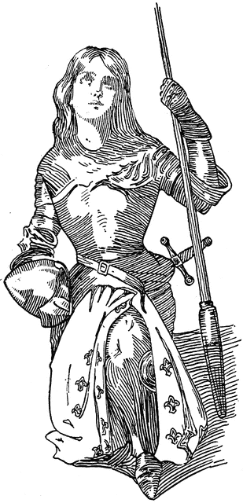Choose one individual from the list provided:

* **Charlemagne (Charles the Great)**
* **Joan of Arc**
* 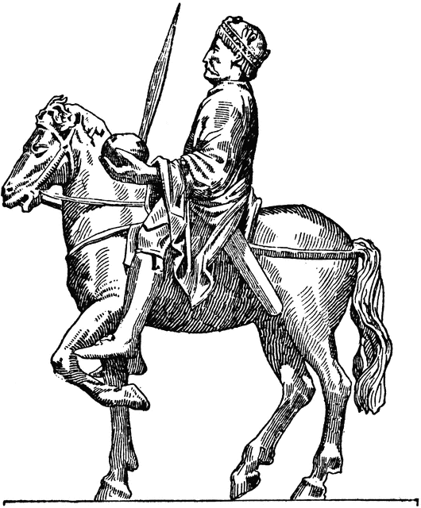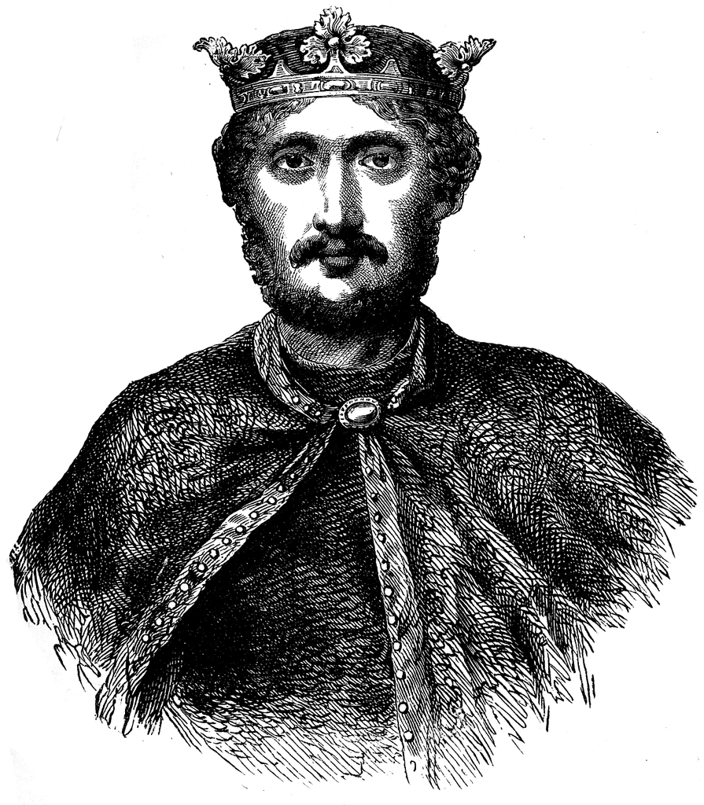**William of Normandy**

You will:

* Complete the inquiry booklet to record your information. You will need to complete the bibliography at the end of the booklet as well. You should use both class time and homework time out of school to complete this assessment.
* Create a museum display (model, poster etc) to communicate your findings.
* Complete an in-class validation. This will be in the form of a scaffolded essay.

**Which significant individual did you choose for this inquiry?**

____________________________________________________

**What do you already know about the topic?** (List or brainstorm everything you have knowledge of relating to this topic.)(1 mark)

**Background/personal information of the significant individual.**

|  |
| --- |
| Birth: (when/where) (1 mark) |
| Parents/ Family background: (Did this impact their standing in society?) (2 marks) |

|  |
| --- |
| Death of significant individual (Where/when) (1 mark) |
| How/why?: (1 mark) |

**Significant individual’s life:**

|  |
| --- |
| A description of their major role in society: (How did they influence other people?) (3 marks) |
| Major events they were involved in: (What was their contribution to key events during their life?) (2 marks) |

**Legacy of the individual: Why is this individual so famous; or why are they remembered in history?**

|  |
| --- |
| (4 marks) |

**Create your own research questions and find information relating to the question.**

|  |
| --- |
| Question 1: (2 marks) |
| Information: (3 marks) |

|  |
| --- |
| Question 2: (2 marks) |
| Information: (3 marks) |

|  |
| --- |
| Question 3: (2 marks) |
| Information: (3 marks) |

|  |
| --- |
| Question 4: (2 marks) |
| Information: (3 marks) |

|  |  |  |  |  |  |
| --- | --- | --- | --- | --- | --- |
| **Author** | **Date last updated** | **Title of Webpage** | **Date accessed** | **HTTP** | |
|  |  |  |  |  | |
|  |  |  |  |  | |
|  |  |  |  |  | |
|  |  |  |  |  | |
|  |  |  |  |  | |
|  |  |  |  |  | |
| **Author** | **Date of Publication** | **Title of Book** | **Publisher** | | **Place of Publication** |
|  |  |  |  | |  |
|  |  |  |  | |  |
|  |  |  |  | |  |

**Reference recording sheet**

*Please note that in order to obtain full marks you must submit a formal bibliography, the table below is only for recording your references as you are researching*

**Bibliography** **(4 marks)**

**Using the reference recording sheet, list the sources according to the authors by placing them in alphabetical order, A – Z. If there is more than two authors, list the name of the first author and add the latin term ‘et al’ which means ‘all the rest, or plural’.**

**Each reference of a source should follow the following format:**

***Author*** *(surname and then initial of first name); then the source’s* ***title*** *(in italics or underlined); then the* ***publisher or full web address****; then the* ***date or year*** *created/produced, and in the case of a website, the* ***date accessed****.*

*e.g.*

Arends, K. Humanities & Social Sciences 8, Pearson, 2017.

Cowley, R. Saladin, from the Readers Companion to Military History, 1996, <https://www.history.com/topics/saladin>, accessed 31/7/18

________________________________________________________________________________________________________________________________________________________________________________________________________________________________________________________________________________________________________________________________________________________________________________________________________________________________________________________________________________________________________________________________________________________________________________________________________________________________________________________________________________________________________________________________________________________________________________________________________________________________________________________________________________________________________________________________________________________________________________________________________________________________________________________________________________________________________________________________________________________________________________________________________________________________________________________________________________________________________________________________________________________________________________________________________________________________________________________________________________________________________________________________________________________________________________________________________________________________________________________________________________________________________________________________________________________________________________________________________________________________________________________________________________________________________________________________________________________________________________________________________________________________________________________________________________________________________________________________________________________________________________________________________________________________________________________________________________________________________________________________________________________________________________

Name: __________________________ *My Target: _____ /38 or ___ %*

Year 8– Historical Inquiry of a Significant Individual

PART B Museum Display (2.5%)

DETAILED MARKING GUIDE/RUBRIC

|  |  |  |  |  |  |
| --- | --- | --- | --- | --- | --- |
| **Task 🡫 &**  **Marks Allocation**  **🡪** | **8-10** | **5-7** | **2-4** | **0-2** | **Subtotal** |
| **Background** | Provides a very detailed description on the background of the chosen individual. The description includes all of the following areas; date of birth, place of birth, parents and early influences. | Provides a detailed description on the background of the chosen individual. The description includes information on most of the following areas; date of birth, place of birth, parents and early influences. | Has briefly outlined the background of the chosen individual. The description includes information on some of the following areas; date of birth, place of birth, parents and early influences. | Has provided little or no description of the background of the chosen individual. |  |
| **Significant individual’s life** | Provides a very detailed description on the career of the chosen individual. The description addresses all of the following areas; key events, methods used to achieve aims, relationships with other individuals. | Provides a detailed description on the career of the chosen individual. The description addresses most of the following areas; key events, methods used to achieve aims, relationships with other individuals. | Has briefly outlined the career of the chosen individual. The description addresses some of the following areas; key events, methods used to achieve aims, relationships with other individuals. | Has provided little or no description of the career of the chosen individual. |  |
| **Legacy** | Provides a very detailed description on the legacy of the chosen individual. This description includes an assessment of the individual’s life and career and how they impacted society. | Provides a detailed description on the legacy of the chosen individual. This description includes a brief summary of the individual’s life and career and how they impacted society. | Has briefly outlined the legacy of the chosen individual. The description makes some mention to how they individual shaped society although it may historically incorrect. | Has provided little or no description of the legacy of the chosen individual. |  |
|  |  | **6-8** | **3-5** | **0-2** |  |
| **Presentation-Visual** |  | Presentation is visually engaging. Displays a high level of detail and presents information about the significant individual to a high standard. It is clear that a lot of time and thought is put into the presentation. | Presentation is engaging. Displays a satisfactory level of detail and overall presents information about the significant individual to satisfactory standard. Some time and thought is put into the presentation. | Presentation is somewhat engaging. Displays limited amount of detail and presents little information about the significant individual. Little time or thought is put into the presentation. |  |
| **TOTAL** | **/38** |

**Overall Comment by Teacher:**

_____________________________________________________________________________________________________

_____________________________________________________________________________________________________

_____________________________________________________________________________________________________

_____________________________________________________________________________________________________

_____________________________________________________________________________________________________